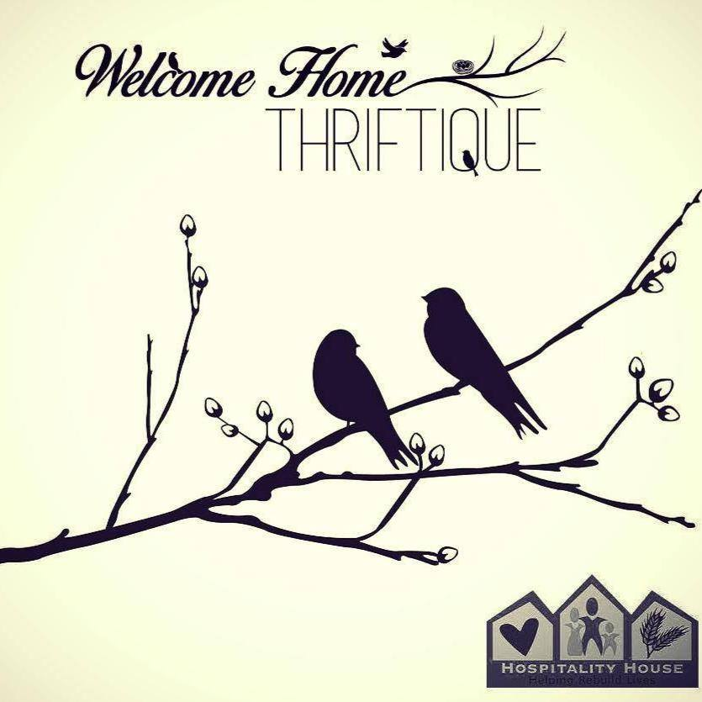

Handbook
&
Staff Guide

Thank you for making the efforts to donate your time to volunteer with Hospitality House and Welcome Home Thriftique! You are much appreciated!

The Welcome Home Thriftique is an extension of the Hospitality House, a crisis agency located in Boone, NC. The store’s purpose is to further connect the organization with the community as well as implement another revenue stream for future funding. The Welcome Home Thriftique will provide Watauga County and surrounding counties with high quality, gently used, and refurbished products in a dynamic thrift shopping experience. Residential interns will have the opportunity to develop and further their skills and experience in the work force. In addition, a financial literacy program will be available to all clients. These opportunities assist clients to build a foundation for a hopeful future as well as serve others along their journey.

Our mission is to serve its clients and the community of the high country by providing an environment to engage the community and offering customers high quality thrift store items. The Welcome Home Thriftique will provide an avenue in which clients can build a foundation for a successful future by taking advantage of internship opportunities and financial literacy programs.

All items in the store are donated by our community. We sell furniture, home goods and décor, antiques and collectables, and name brand clothing. We strive to provide a well presented store, with quality upscale items and a friendly staff of volunteers and interns to provide the best customer service and knowledge about our mission for the community. In addition, we will be offering job skill training and financial literacy courses for Hospitality House clients to assist them with achieving their goals and uphold the mission of Hospitality House.

Welcome Home Thriftique Staff Structure and Job Descriptions

- Project Manager
  - The project manager over sees the operating procedures for the Welcome Home Thriftique including recruiting and managing volunteers and interns, cultivating donations for the store, overseeing the pricing and merchandising of items, and managing marketing and promotions. The project manager also organizes the Color Blast 5K on Memorial Day as well as other fundraisers to assist with operating costs for the thriftique. In addition, the project manager is also responsible for overseeing the job skills training and financial literacy programs within the thriftique.
- Volunteer Staff Manager
  - The volunteer staff manager is the acting manager when the project manager is not available. The AVS has the authority to open and close the store when the project manager is unavailable in addition to the regular volunteer staff member.
- Advanced Volunteer Staff
  - The AVS is a position held by volunteers who show commitment to the project and have proved ability to handle extra tasks to assist with day to day operations. AVS will be able to assist with register management in addition to the responsibilities of an intro volunteer. VST members will also be trained as a community mentor to the client interns, assisting with the job skills training and financial literacy programs.
- Intro Level Volunteer Staff
  - Members of the volunteer staff team play an important role in the operation of the store and project. IVS assist with donation collection, sorting, pricing and merchandising, customer relations, and maintaining a clean and well-presented store front. In addition, IVS may need to assist with additional small projects within the store such as painting, repairing, etc.
- Community Mentor
  - An advanced volunteer staff member that works alongside client inters in the job skills training program and financial literacy program and assists with the hands on training component of the programs.
- Client Intern
  - The client internship is offered to those individuals receiving services from Hospitality House. The internship offered at WHT is a hands-on component of the job skills training program. Interns can expect professional development in a business setting as well as experience in customer relations, cash register management, business presentation, marketing and promotions, and overall management skills.

- Once client interns complete the job skills training program, they are eligible to apply to be an AVS.

Volunteering

All staff volunteers and client interns must sign in at the beginning of their shift in the volunteer binder in the back office. Before you leave, make sure to sign out your time.
There will be a calendar to sign up for volunteer hours. Sign your name and the times you can work. Volunteers and interns are expected to show up for all shifts they sign up for. Welcome Home Thriftique fully relies on the help of volunteers. It is very important to show up for the times you commit to. The first shift you fail to show up for, a warning will be given. The second no show will result in dismissal from the Welcome Home Thriftique staff program.
If you cannot make a shift, please try to call 1-2 days in advance to inform the manager. If you cannot make it due to a sickness, please call in as soon as possible and inform the manager. You may be asked to provide a Dr.’s note.
There will be a daily list of tasks that need to be completed for the day. Once the task is complete, the staff member will need to initial on the list to let others know the task is complete.
Task may include: Dusting, sweeping, vacuuming, mopping, window washing, sorting donations, pricing items, etc.

Dress Code
In retail, sales associates are often seen as a reflection of the brand and business.
At Welcome Home Thriftique, you are not only representing the store, but Hospitality House as well. It is important that all staff volunteers and interns wear clothing that projects a respectable and professional image.
Closed toed shoes are suggested since some days you may be required to move furniture and other item.
Low cut shirts, sagging pants, and other “revealing” clothing will not be allowed while you are volunteering at the thriftique.
All staff volunteers and interns must be “well groomed” and neat.

Sexual Relations
Under no circumstances are any staff volunteers and/or interns allowed to develop a personal relationship with any Hospitality House client.
Hospitality House strictly prohibits romantic or sexual relations between volunteers and clients of any Hospitality House program.
Failure to abide by this policy will result in dismissal of the Welcome Home Thriftique staff program.

Substance Use
Welcome Home Thriftique is a drug free workplace. Any staff volunteer or intern working under the influence of drugs and/or alcohol will not be tolerated at Welcome Home Thriftique.
llegal substances of any kind and alcohol are not permitted on the property. Failure to abide by this policy will result in dismissal of the Welcome Home Thriftique staff program.

Customer Service
If it VERY important that we treat all who walk in the door, (clients, customers, donors, interns, volunteers) with top respect. Always greet each person with “Hello! How are you?” or “Hi there! Welcome Home!” and always smile and be polite. When checking out customers or when they exit the store, ALWAYS thank them for coming in.
Many customers are curious about the business. It is very important that we tell our story in a very clear and short matter. We recommend that you say “We are a nonprofit thrift store for Hospitality House of Boone. All items are donated by the community and 100% of the profits go to support programs and services offered at Hospitality House.”
It makes a big difference when the customer knows why we exist.
You will often be asked if we can negotiate prices. ALL prices are as marked. Negotiations are not allowed. If you are asked, politely respond with “I am very sorry, but our store supports a local nonprofit and I am unauthorized to make any changes to prices.”
Always offer any assistance to customers, donors, etc. if they need help carrying an item in or out of the store or if they need help searching for a specific item.
Use proper phone etiquette when answering the business phone. Answer with “Thank you for calling Welcome Home Thriftique. This is ____________. How may I help you?”

Remember the golden rule: treat others as you would like to be treated.

Donations
Welcome Home Thriftique accepts donations of furniture, home goods and décor, antiques and collectables, and name brand clothing.
We do NOT accept: Mattresses, bathing suits, and undergarments.
If anyone brings a donation to the store, unless it is a mattress, always accept the donation no matter what. Items will be sorted and what we do not sell will be donated to Goodwill in the name of Hospitality House. In return, Goodwill sends us gift cards for our clients.
Always ask the donor if they would like a receipt. (See example) The donor receives the yellow copy and Welcome Home Thriftique receives the white copy. ALWAYS thank the donor and let them know how much we appreciate them.
Place donations in the back office to be sorted, cleaned, and priced.
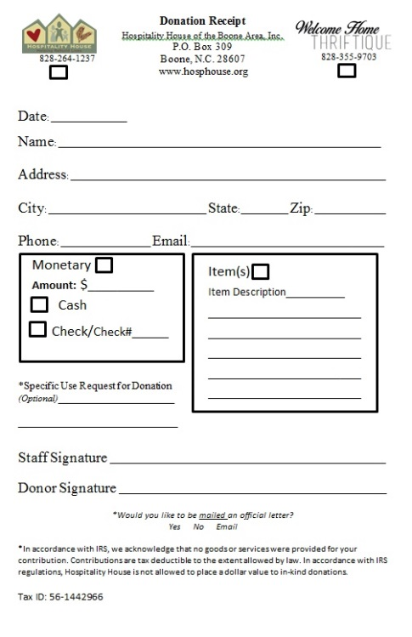
Make sure this box is checked!
Make sure the entire form is filled out.

Don’t forget to sign!

HH Tax I.D. # (allows this form to be used towards taxes)
Always ask if they would like a formal letter

Merchandising
After donations are sorted, all items must be cleaned. All items are to be wiped down with the proper cleaning solution, all “Goo” , stickers, etc. must be removed using Goo Gone, and all glass must be cleaned properly. Once sorted, cleaned, and priced, place item in the proper category in the storage room.
All cleaning supplies, protective gloves, and masks are provided by Welcome Home Thriftique.
Once items are cleaned, priced, and categorized, when an available spot opens up on the sales floor, place item neatly and well presented to be sold. Do not block walkways, clutter the area, or remove an item from its place. Presentation is very important. Welcome Home Thriftique should look nice and presentable at all times.

Pricing
Each item that is donated to Welcome Home Thriftique must be cleaned and priced before being placed on the sales floor. Every item must be researched as a used item on eBay, Amazon, Google Shopping, and/or Replacements. The following pricing guide must be followed to assign a reasonable and correct price.
Percentages below are to be taken off the highest price researched.
Example: Researched price: $145 (Luxury Brand) we would sell it for $87 (Because 60% of 145 is $87).

Art: 50%
Clothing (including purses): Luxury Brands: 60%
Name Brands: 40%
*Please refer to band list in the back office!

Furniture: High Level: 75% Great condition
Medium Level: 50% some scratches frayed fabric, faded, etc.
Low Level: Consult with manger
Home Goods: 40% (Dishes, pots, pans, table clothes, etc.)
Home Décor: 40% (Frames, Vases, candlesticks, lamps/shades, etc.)
Antiques & Collectables: 60% (MUST research well)

Unless instructed otherwise, these prices below are constant:
Books $3.
Shoes $5.
Socks $2. Hats $3.
Jewelry: Necklaces and bracelets are always $3
Earrings are always$1.
Watches are always $10.
If at ANY time you are unsure of an item, please consult with a manager.
Once an item is researched and a priced, the staff member is to write the price, date, and staff members initials on a post it note provided and then place on item.

Policy Acknowledgement for the Welcome Home Thriftique Volunteer Agreement
This packet has been prepared for your information and understanding of the agreements, policies, protocols, and practices of the Hospitality House of Boone. Please read it carefully. Upon completion of your review of this packet, please initial and date each page and then sign the statement below.

I, ____________________, have received and read a copy of the Volunteer Application which outlines the goals, policies, and expectations of the shelter, as well as my responsibilities as a volunteer. I agree to abide by these guidelines as a condition of my tenure at the Hospitality House.

I understand that if I have questions, at any time, regarding the agreement or related policies, I will consult with my immediate supervisor or staff members.
I understand that this is not a contract of employment and should not be deemed as such.
By my signature below, I acknowledge, understand, accept and agree to comply with the information contained in the Volunteer Agreement provided to me by the Hospitality House. I understand this is not intended to cover every situation which may arise during my tenure, but is simply a general guide to the goals, policies, practices, and expectations of the shelter.

Your signature below indicates that you thoroughly understand and accept these policies as a condition of your volunteer work and that any violation of any of these provisions may result in disciplinary action by Hospitality House against you, up to and including immediate termination. Please read the policies carefully to ensure that you understand them before signing this document
I have read and understand this notice and agree to follow it.

Volunteer Signature: _______________________________________ Date: _________________________
Volunteer Printed Name: ____________________________________

Staff Member Signature: ____________________________________ Date: _________________________
Staff Member Printed Name: ____________________________________

Witness Signature: _______________________________________ Date: _________________________
Witness Printed Name: ____________________________________

